WordPress on AWS Lightsail
Project Title: Deploying a WordPress Website on AWS Lightsail

Introduction
This project demonstrates the deployment of a WordPress website using Amazon Web Services (AWS) Lightsail. AWS Lightsail is a simplified cloud platform that allows users to create virtual servers and host websites easily. In this project, a WordPress instance was launched, configured, and accessed through a public IP address.
The project helped in understanding cloud hosting, virtual servers, WordPress management, and basic AWS services.

Objectives
- To learn cloud hosting using AWS Lightsail
- To deploy a WordPress website on the cloud
- To understand instance creation and management
- To access and manage WordPress through the admin dashboard
- To create a basic e-commerce style website using WordPress

Technologies Used
Technology | Purpose
AWS Lightsail | Cloud hosting platform
WordPress | Content management system
Linux | Operating system
Apache | Web server
MariaDB | Database
PHP | Server-side scripting

AWS Services Used
Amazon Lightsail
Amazon Lightsail is a cloud service provided by AWS that helps users deploy websites and applications quickly using preconfigured virtual machines.

Architecture
User Browser → Internet → AWS Lightsail Instance → WordPress Website

Steps Performed
Step 1: Login to AWS Console
- Opened the AWS Management Console.
- Entered AWS account email and password.
- Clicked on “Sign In”.
- Searched for “Lightsail” using the AWS search bar.
- Opened the Amazon Lightsail service.

Step 2: Create WordPress Instance
- Clicked the “Create Instance” button.
- Selected the nearest region (Mumbai – ap-south-1).
- Chose the platform as “Linux/Unix”.
- Under blueprints, selected “WordPress”.
- Selected the basic Lightsail instance plan.
- Entered the instance name as “pavithra-wordpress”.
- Clicked “Create Instance”.
- Waited for the instance status to change to “Running”.

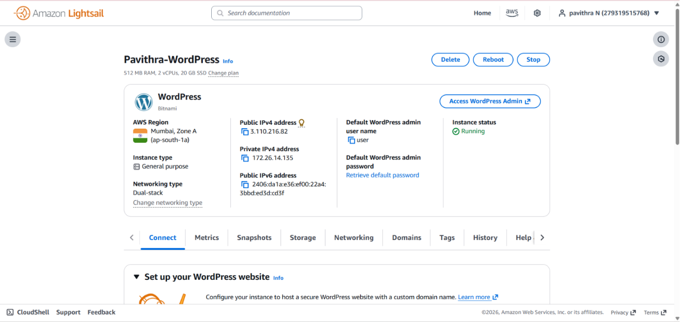

Step 3: Open the WordPress Website
- Opened the created Lightsail instance.
- Copied the public IP address.
- Opened a browser tab.
- Entered the public IP address using HTTP.
- Verified that the WordPress website loaded successfully.
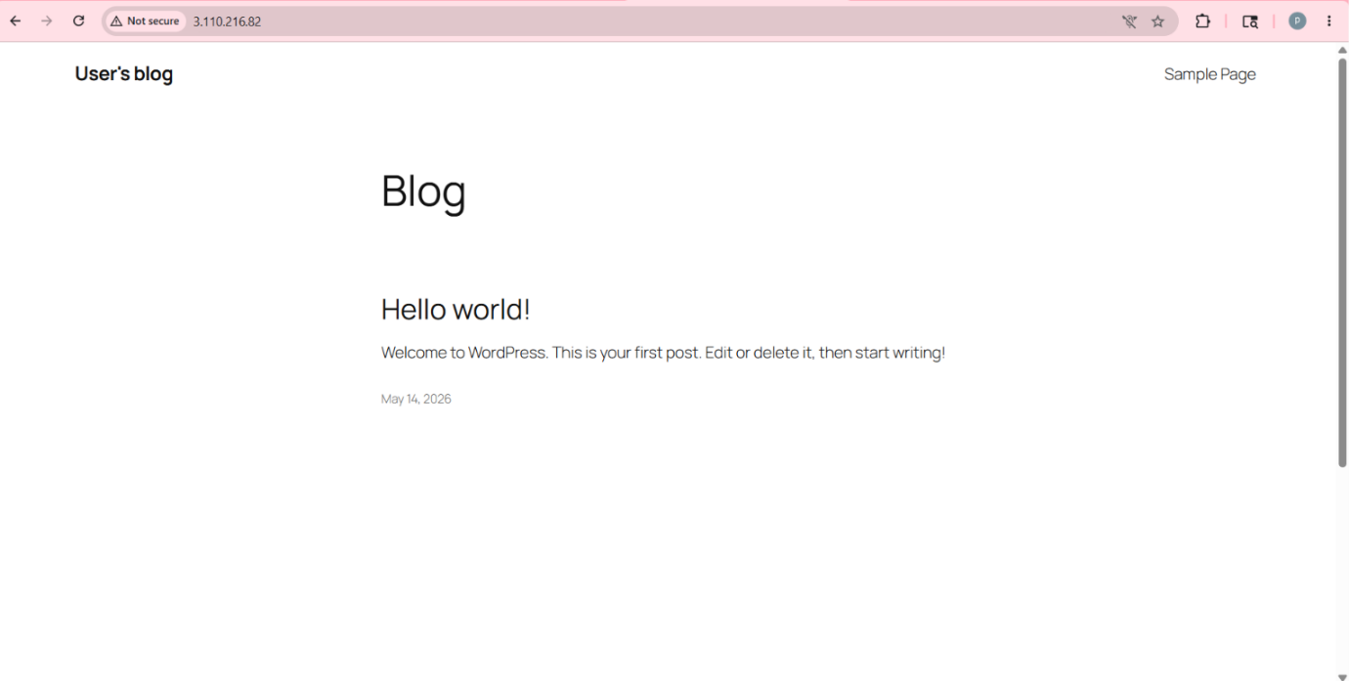
Step 4: Connect Using SSH
- Opened the Lightsail instance page.
- Clicked “Connect using SSH”.
- Opened the browser-based terminal.
- Accessed the Linux server terminal successfully.

Step 5: Retrieve WordPress Password
- Inside the SSH terminal, executed the command:
cat bitnami_application_password
- Retrieved the automatically generated WordPress admin password.
- Copied the password securely.
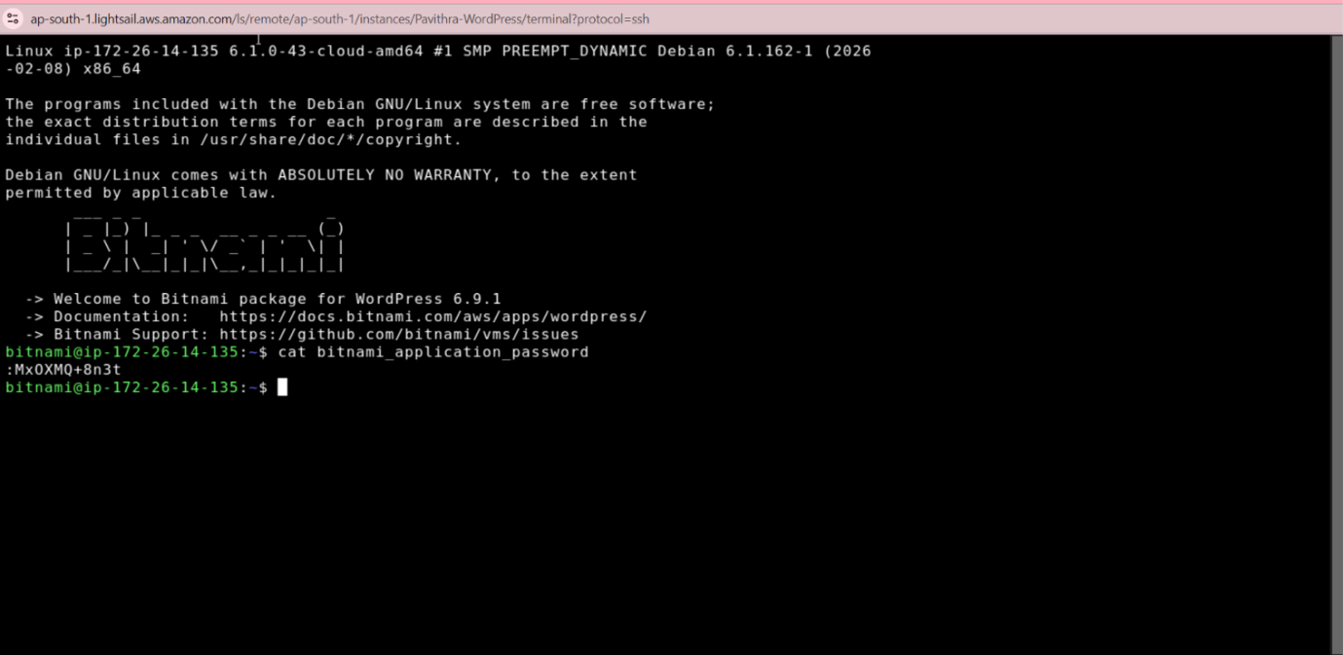

Step 6: Login to WordPress Dashboard
- Opened a new browser tab.
- Entered:
http://PUBLIC_IP/wp-admin
- Entered the username as “user”.
- Entered the password obtained from the terminal.
- Clicked “Log In”.
- Accessed the WordPress admin dashboard successfully.

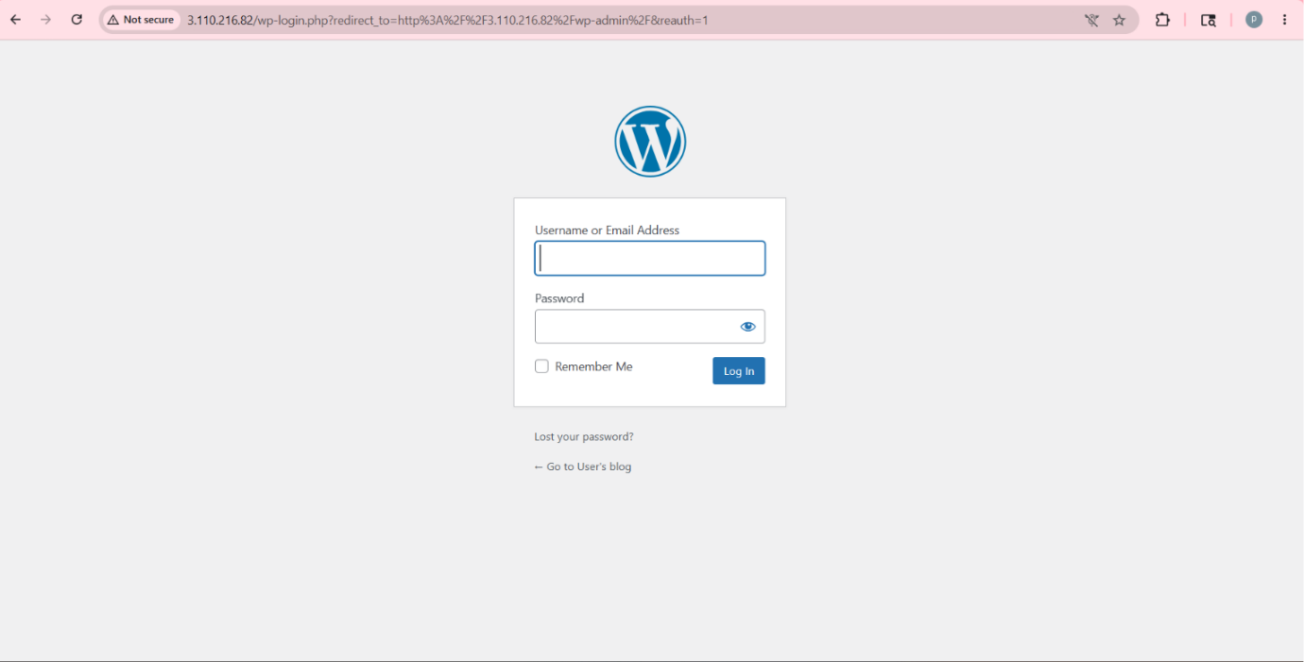

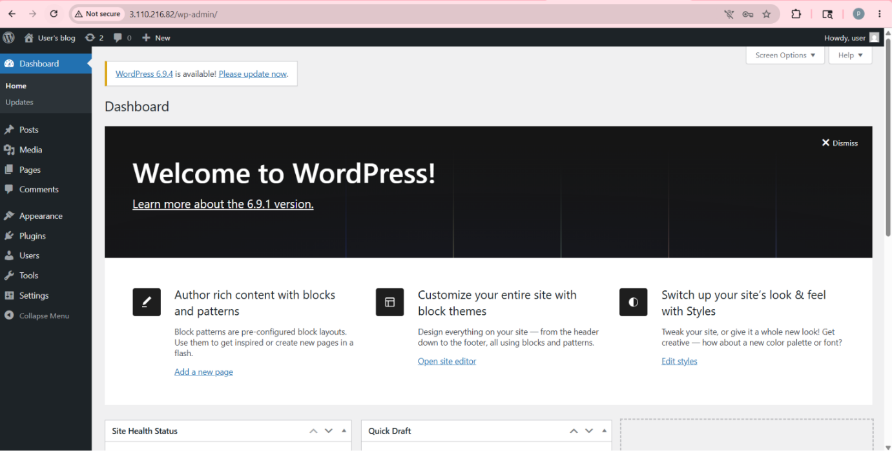

Step 7: Configure Website Settings
- Opened “Settings → General”.
- Changed the website title to “Pavi Store”.
- Updated the tagline.
- Saved the changes.
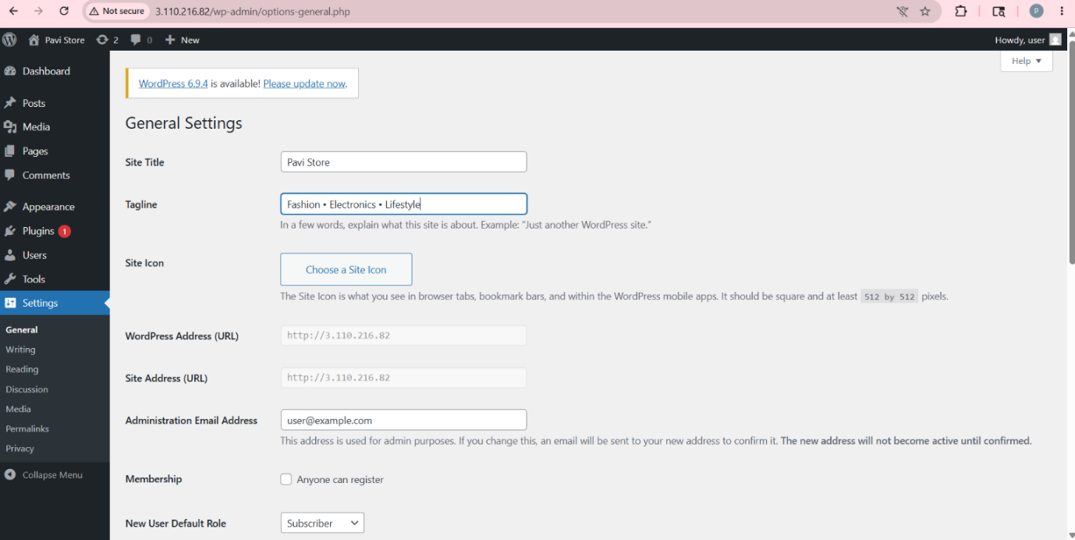

Step 8: Install Theme
- Opened “Appearance → Themes”.
- Clicked “Add New Theme”.
- Searched for the “Astra” theme.
- Clicked “Install”.
- Clicked “Activate”.
- Applied the theme successfully.
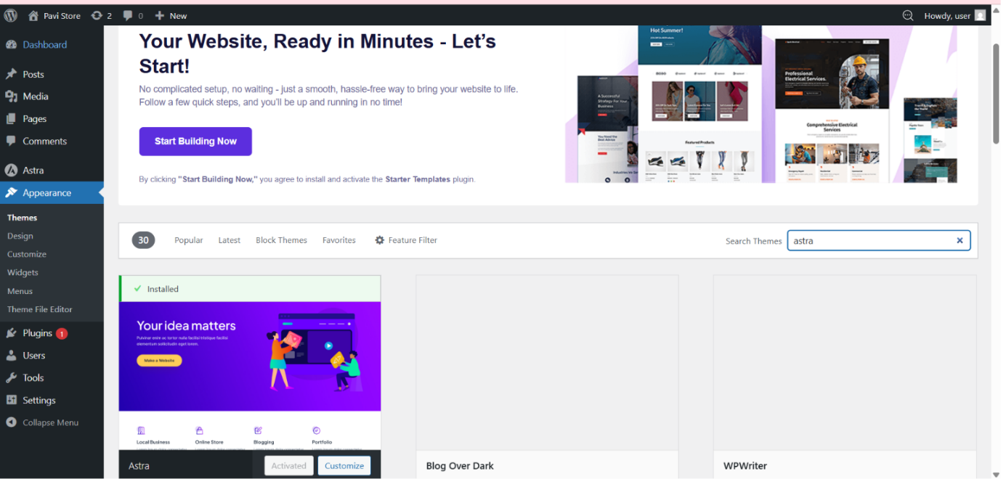

Step 9: Install WooCommerce Plugin
- Opened “Plugins → Add Plugin”.
- Searched for “WooCommerce”.
- Clicked “Install Now”.
- Activated the plugin.
- Completed the WooCommerce setup wizard.
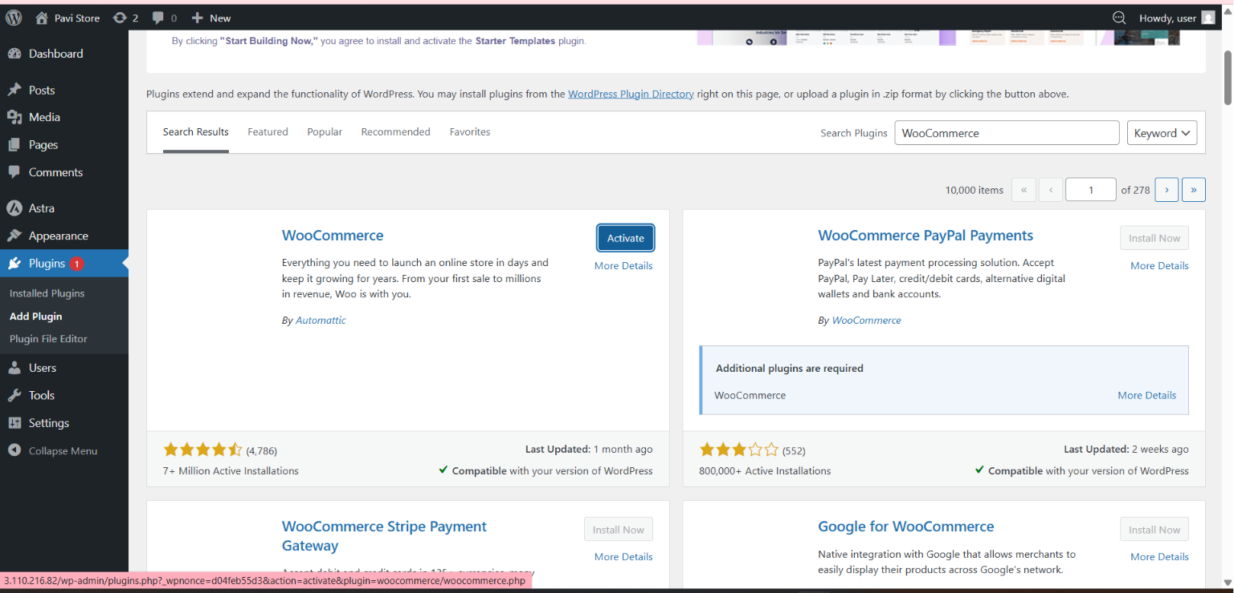

Step 10: Add Products
- Opened “Products → Add New”.
- Entered product title and description.
- Added product pricing.
- Uploaded product images.
- Clicked “Publish”.
- Verified that products appeared on the website.
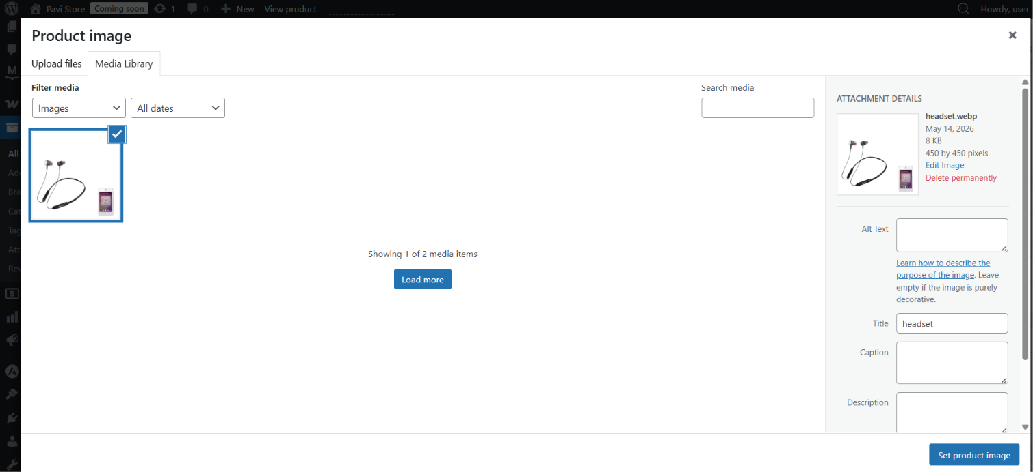

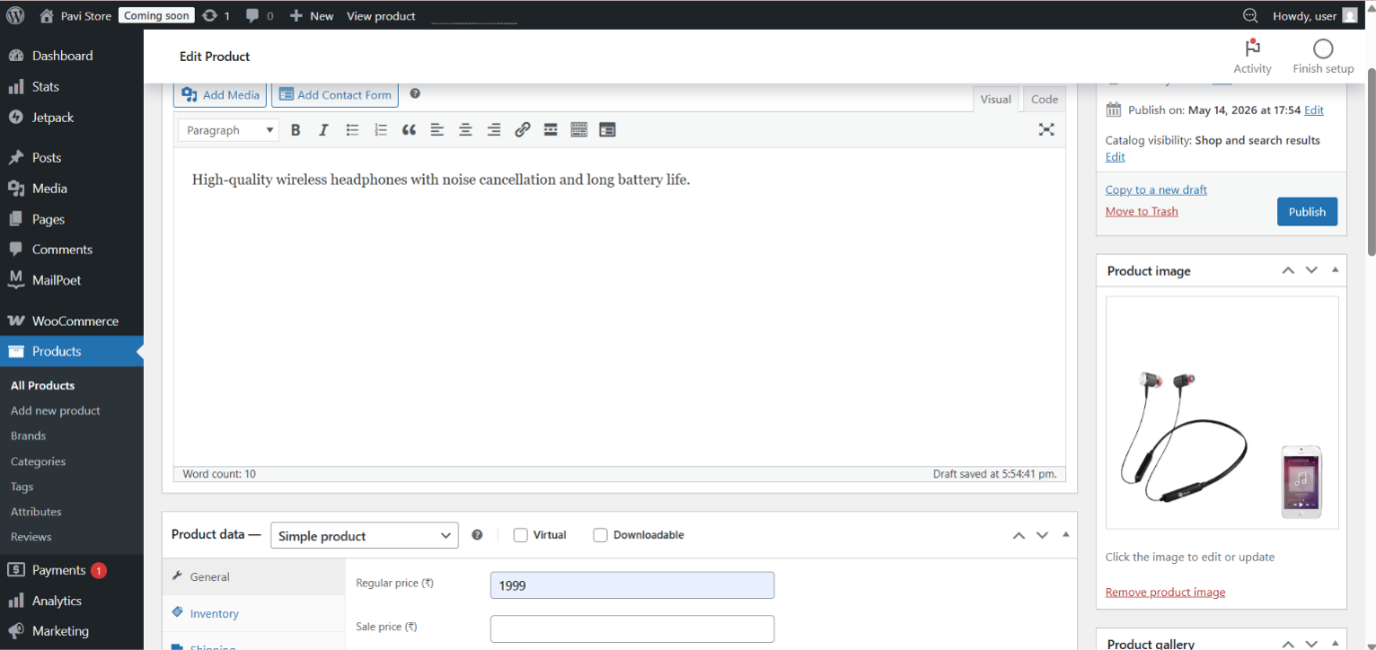

Step 11: Create Website Pages
- Opened “Pages → Add New”.
- Created pages:
  - Home
  - About Us
  - Contact Us
  - Products
- Added relevant content to each page.
- Published the pages.
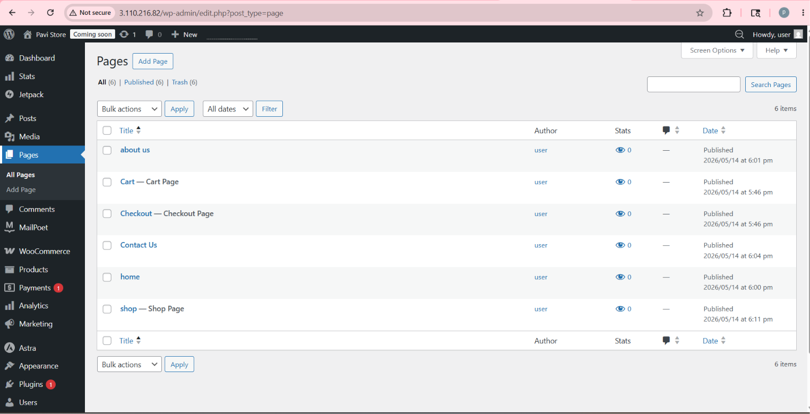

Step 12: Configure Home Page
- Opened “Settings → Reading”.
- Selected “A static page”.
- Set “Home” as the homepage.
- Saved changes.
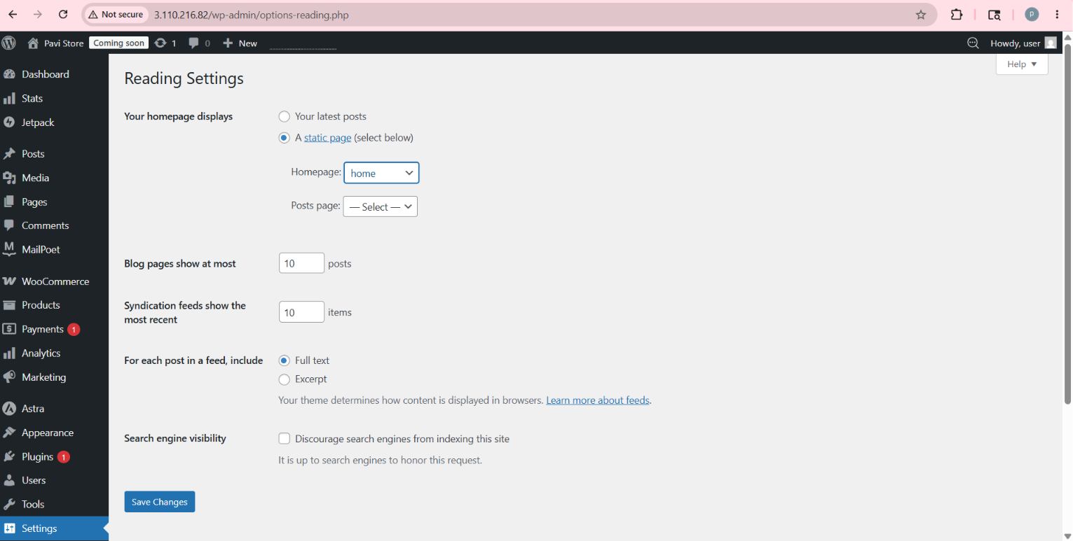

Step 13: Configure Firewall Rules
- Opened the Lightsail Networking tab.
- Verified firewall rules for:
  - HTTP (80)
  - HTTPS (443)
  - SSH (22)
- Added missing rules if required.
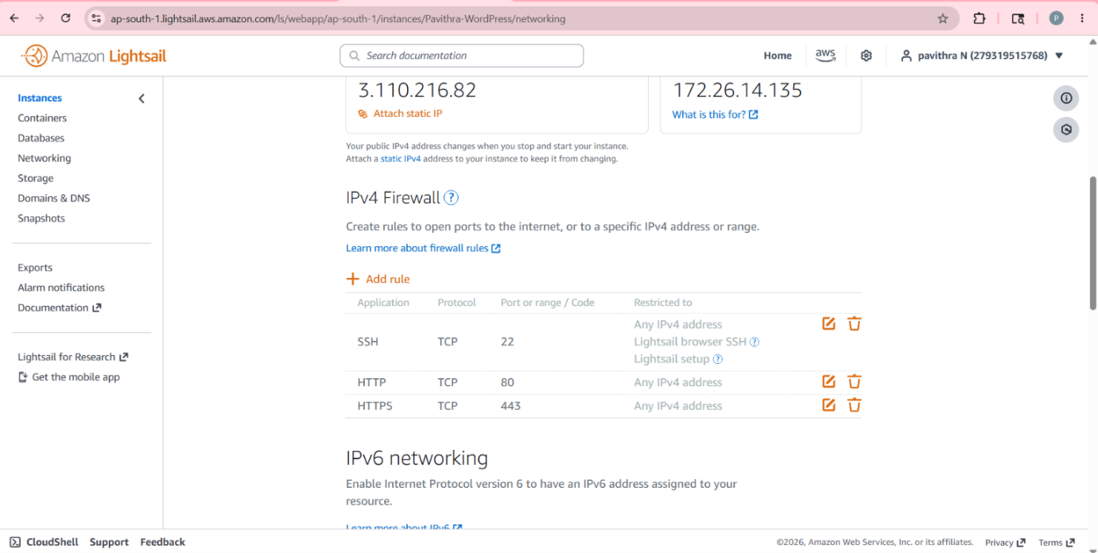

Step 14: Create Static IP
- Opened the Networking section in Lightsail.
- Clicked “Create Static IP”.
- Attached the static IP to the WordPress instance.
- Ensured the public IP remained permanent.
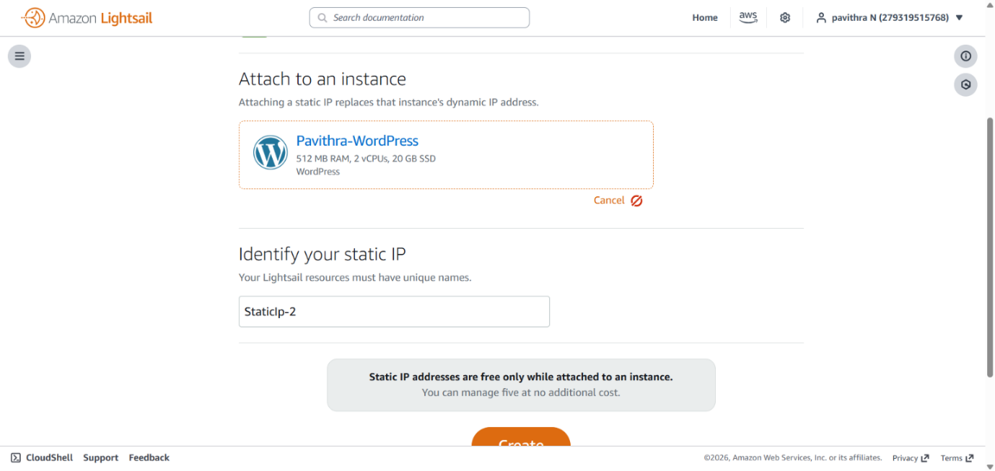

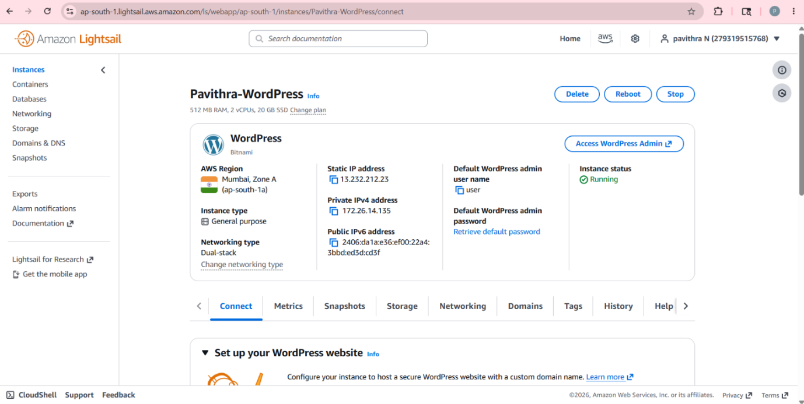

Step 15: Website Testing
- Opened the website using the public IP.
- Verified that pages loaded correctly.
- Checked product visibility.
- Confirmed website accessibility through browser.

Advantages of AWS Lightsail
- Easy to use
- Beginner friendly
- Fast deployment
- Low cost hosting
- Preconfigured WordPress setup

Challenges Faced
- Incorrect blueprint selection initially
- Firewall configuration issues
- Website connection errors
- Understanding SSH access

Outcome of the Project
The project was completed successfully by deploying a live WordPress website on AWS Lightsail. The website was accessible through a public IP address and managed using the WordPress dashboard.
This project improved understanding of:
- Cloud computing
- Website hosting
- AWS services
- WordPress management
- Linux server access

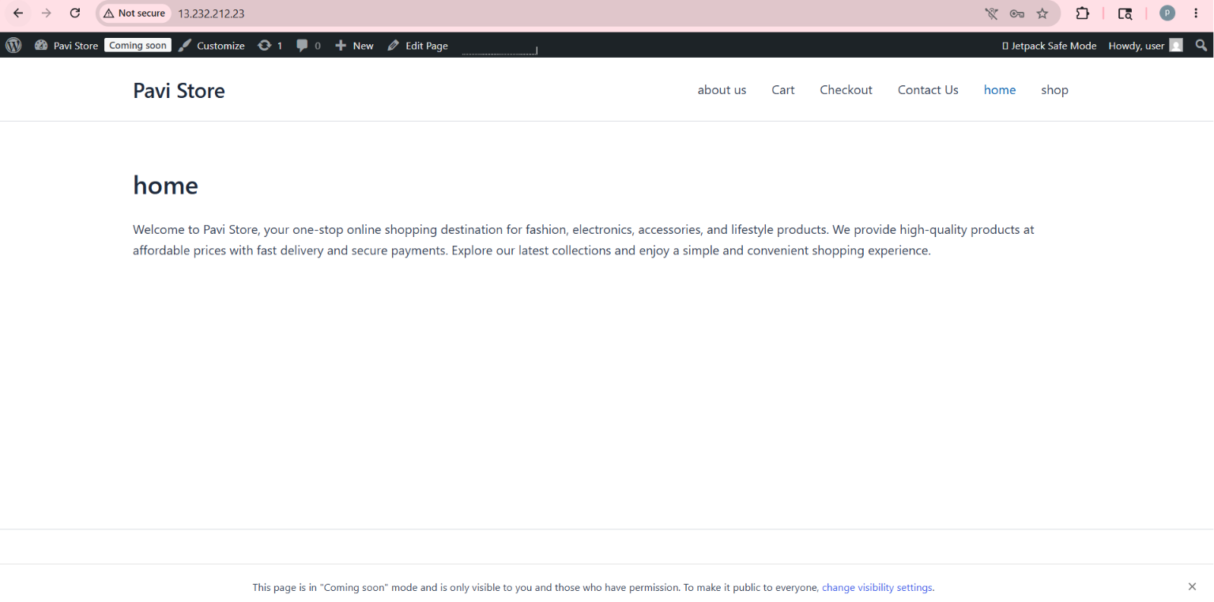
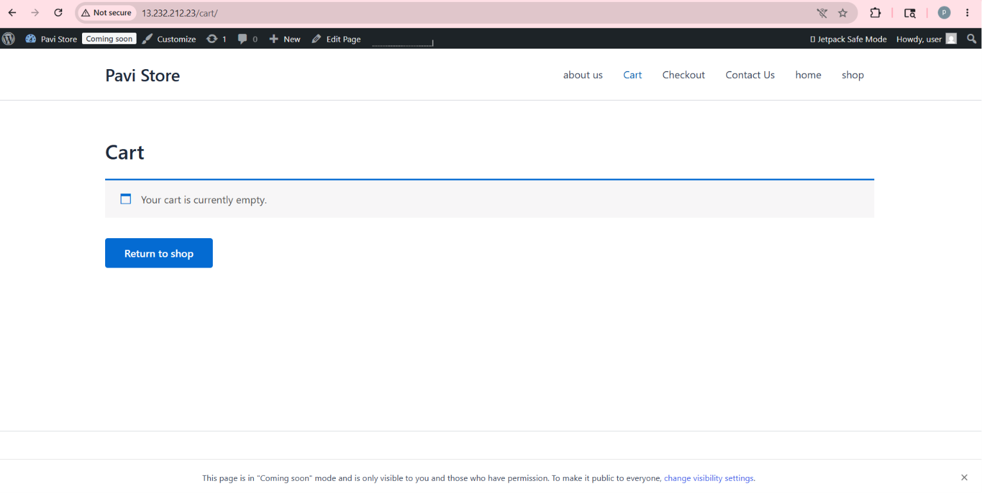

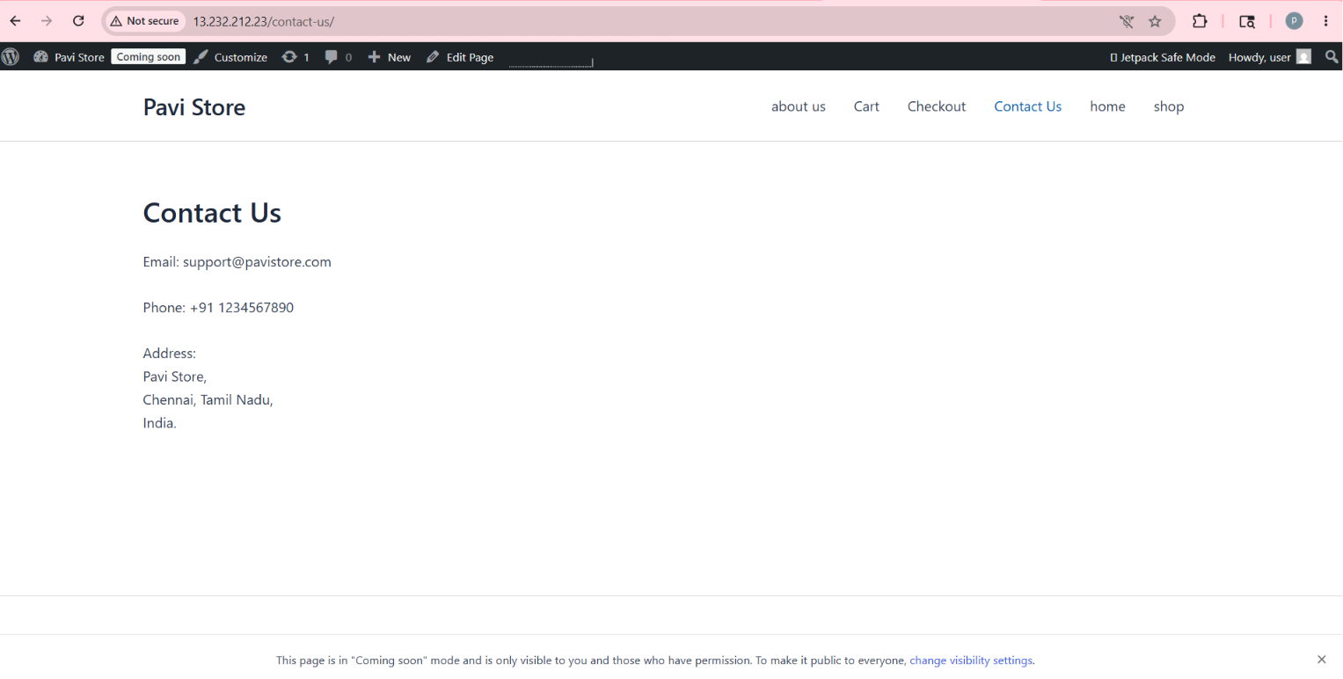

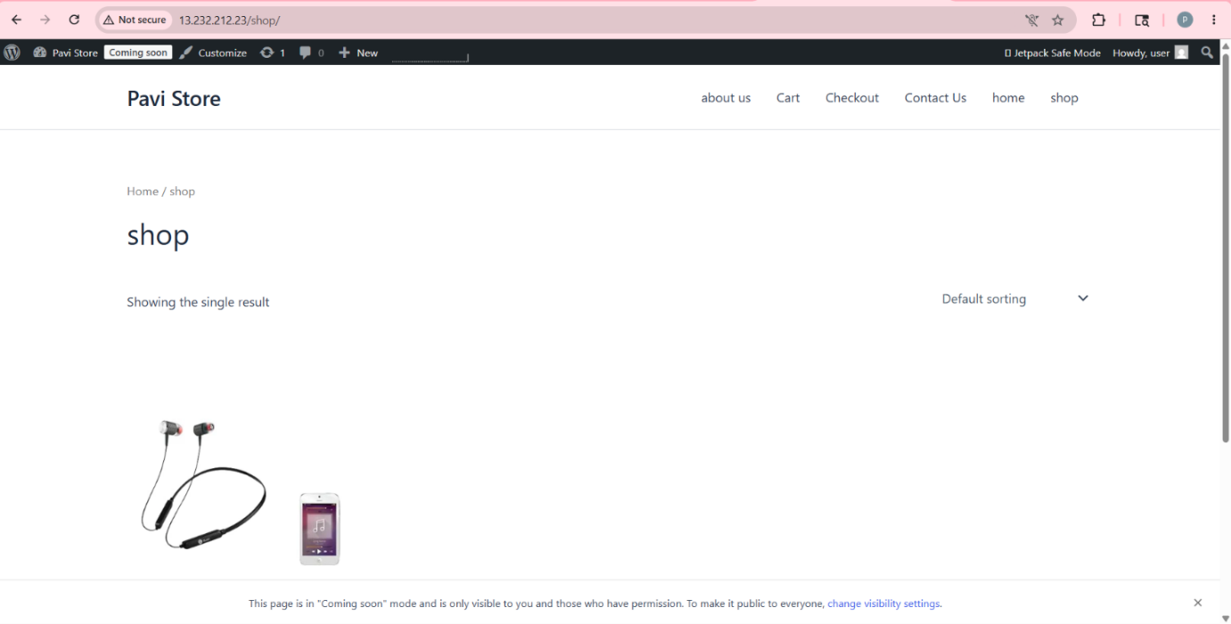

Conclusion
Deploying WordPress on AWS Lightsail is a simple and effective method for hosting websites in the cloud. This project provided practical knowledge about AWS cloud services, server configuration, and website management. AWS Lightsail makes cloud hosting easy for beginners and students.

